**STIA1123 Programming 2**

**Lab Exercise: User Defined Class**

1. What will be the output from the following code?

class QuestionOne {

private int count;

public void init(){

count = 1;

}

public void increment() {

count = count + 1;

}

public int getCount() {

return count;

}

}

public class Q1Main {

public static void main (String []arg) {

QuestionOne q1;

q1 = new QuestionOne();

q1.init();

q1.increment();

q1.increment();

System.out.println(q1.getCount());

}

}

Next, replace the init() method with a constructor. Modify the main() method.

The first output before replace the init() method is: 3 .

public class Q1Main {

public static void main(String[] args) {

QuestionOne q1;

q1 = new QuestionOne();

q1.setInit();

q1.increment();

q1.increment();

System.out.println(q1.getCount());

}

}

public class QuestionOne {

private int count;

public void setInit(){

count = 1;

}

public void increment() {

count = count + 1;

}

public int getCount() {

return count;

}

}

And the output after replace init() method with a constructer setInit() is also same : 3

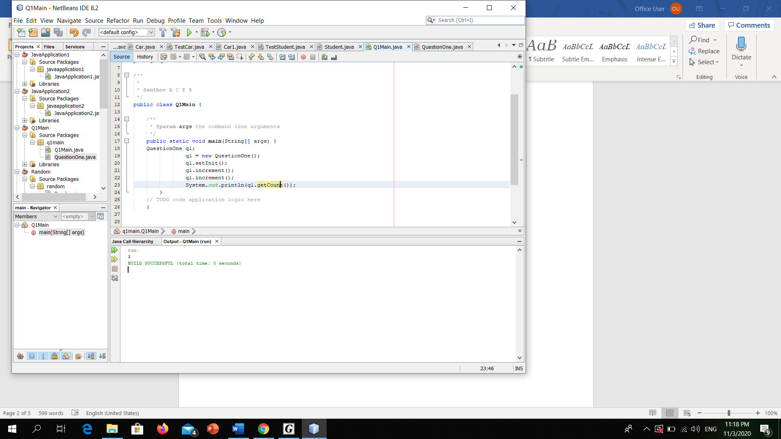

1. Read and analyse the following class:

class Staff {

private String name, staffID;

private double salary;

private int workingDay;

public void setStaffInfo(String nm, String id, int wDay){

name=nm;

stafID=id;

workingDay=wDay;

}

public void calculateSalary(){

salary = workingDay * 35.0;

}

public double getSalary(){

return salary;

}

public String getName(){

return name;

}

public String getStaffID(){

return staffID;

}

}//end class

1. Draw a UML class diagram for Staff class.

|  |
| --- |
| Staff |
| Attribute/State  -name : String  -staffID : String  -salary : double  -workingDay : int |
| Behavior /method  +setStaffInfo(String nm, String id, int wDay)  +calculatesalary() : void  +getsalary() : double  +getName() : String  +getStaffID : String |

1. By using the above class, complete the following class TestStaff that accepts name, staff id and working perday as inputs from the user and displays the name, staff ID and salary of the staff.

import java.util.Scanner;

class TestStaff {

static Scanner console = new Scanner(System.in);

public static void main(String arg[])

//declare input as a string name,staffid, int workingDay, double salary;  
 String name, staffID;  
 int workingDay;  
 double salary;  
  
 Staff s1 = new Staff(); //object  
 System.out.print("Name:");  
 name = console.nextLine();  
 System.out.print("Staff ID:");  
 staffID = console.nextLine();  
 System.out.print("workingDay:");  
 workingDay = console.nextInt();  
  
 //display staff info  
 s1.setStaffInfo(name,staffID,workingDay);  
 s1.calculateSalary();  
 System.out.println("************************");  
 System.out.println("STAFF INFORMATION");  
 System.out.println("************************");   
 System.out.println("Staff Name: " + s1.getName());  
 System.out.println("Staff ID: " + s1.getStaffID());  
 System.out.println("Staff working per day: " + s1.getWorkingDay() + "days");  
 System.out.println("Staff salary:" + "RM" + s1.getSalary());  
   
 }  
}//end main  
  
class Staff {  
 private String name, staffID;  
 private double salary;  
 private int workingDay;  
 private double calculateSalary;  
   
 public void setStaffInfo(String nm, String id, int wDay){  
 name = nm;  
 staffID = id;  
 workingDay = wDay;  
  
 }  
 public void setName(String nm){  
 name = nm;  
 }  
 public void setStaffID(String id){  
 staffID = id;  
 }  
 public void setWorkingDay(int wDay){  
 workingDay = wDay;  
 }  
 public void calculateSalary(){  
 salary = workingDay * 35.0;  
 }  
   
 public double getSalary(){  
 return salary;  
 }  
 public String getName(){  
 return name;  
 }  
   
 public String getStaffID(){  
 return staffID;  
 }  
 public int getWorkingDay() {  
 return workingDay;  
 }  
   
} //end class staff

1. Understand and analyze the problem below:

Staffs at MyFC earn the basic hourly wage of RM8.00. They will receive a commission on the sales they generate while tending the counter. The commission is based on the following formula:

|  |  |
| --- | --- |
| **Sales Volume** | **Commission** |
| RM150.00 to RM300.00  RM301.00 to RM500.00  Above RM500.00 | 5% of total sale  10% of total sale  15% of total sale |

Based on above scenario:

* Write a Java program that accepts staff’s information (including name and staffID), total hours work and total sales for that particular month and then displays total salary that he/she earned. You are required to create 2 classes named MyFCStaff and TestMyFCStaff. Declare appropriate data members for the class MyFCStaff and include the following methods as well:
  + **Constructor** - to initialize name, staffID, total hours work and total sales for that particular month with values that are received through the parameters of the method.
  + **calculateCommission()** - calculates the commission based on the sales volume.
  + **calculateSalary()** - calculates the total salary
  + **displaySalary()** - displays the output similar as shown below

Staff Name : Ali

StaffID : MyFC1001

Hours Work : 200

Total Sale : RM 4500.00

Total Salary : RM 2275.00

* The class TestMyFCStaff will contain the main method that consists of the statements to read the user input and invoke the methods of the class MyFCStaff.

1. Modify the class MyFCStaff by replacing the **displaySalary()** method with the method toString() that returns all required information to be displayed as the output as shown in the above. You should then include printing statements (S.O.P) in the main method. Please ensure that you should get the same expected output as in the **Question (3**).

import java.util.Scanner;  
public class TestMyStaff {  
  
 private static double salary;  
 private static double sales;  
  
 public static void main(String[] args) {  
 String name,staffID;  
 int hourWorks;  
 MyFCStaff FC = new MyFCStaff();  
   
 Scanner scan = new Scanner (System.in);  
 System.out.print("Enter staff name: ");  
 name = scan.next();  
 System.out.print("Enter staff ID:");  
 staffID = scan.next();  
 System.out.print("Enter staff sales:");  
 sales = scan.nextDouble();  
 System.out.print("Enter hour works:");  
 hourWorks = scan.nextInt();  
   
 FC.setStaff(name,staffID,hourWorks,sales,salary);  
 FC.calculateSalary();  
 FC.calculateCommission();  
 FC.displaySalary();  
 }  
}  
  
class MyFCStaff {  
  
 private String name,staffID;  
 private int totalHourWorks;  
 private double sales,salary,commission,totalSales;  
   
 public void setStaff(String nm, String id, int hWorks, double sales, double salary){  
 name = nm;  
 staffID = id;  
 totalHourWorks = hWorks;  
 this.sales = sales;  
 this.salary = salary;  
 }  
   
 public void setName(String nm){  
 name = nm;  
 }  
   
 public void setStaffID(String id){  
 staffID = id;  
 }  
 public void setHourWorks(int hWorks){  
 totalHourWorks = hWorks;  
 }  
   
 public String getName() {  
 return name;  
 }  
   
 public String getStaffID(){  
 return staffID;  
 }  
   
 public int getTotalHourWorks() {  
 return totalHourWorks;  
 }  
   
 public void calculateSalary() {  
 salary = (totalHourWorks * 8 ) + commission;  
 }  
   
 public double getSalary(){  
 return salary;  
 }  
   
 public void calculateCommission() {  
 if (sales >= 150 && sales <= 300)  
 commission =(int) sales * 0.05;  
 else if (sales >= 301 && sales <= 500)  
 commission = (int)sales * 0.1;  
 else if (sales > 500)  
 commission = (int)sales * 0.15;  
 else commission = 0;  
 }  
   
 public double getTotalSales(){  
 return commission;  
 }  
   
 public void displaySalary(){  
 System.out.println("*****Staff Information*****");  
 System.out.println("Staff Name : " + name);  
 System.out.println("StaffID : " + staffID);  
 System.out.println("Hours Work : " + totalHourWorks);  
 System.out.println("Total sales : " + "RM" + sales * commission);  
 System.out.println("Total Salary : " + "RM" + salary);  
 System.out.println("**********************");  
   
 }  
 }